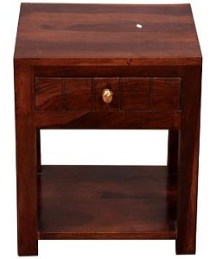

Simple Side Table

$19.60

Availability: In stock

### Description

Simple brown wood side table with drawer. The profine wardrobe have a lacquered internal wood structure with the use of special metallic colors in addition to the outer coating. The structure of profine wardrobe is made of wood which is subsequently lacquered with special paints.  The tubular base is adjustable and equipped with feet.